**Name = Junaid**

**E.no : 02-131202-057**

**Craete Database Galleries**

create database Galleries

create table Artist(

ArtistName varchar(30) not null primary key,

Birthplaces varchar(55) not null ,

age int not null,

Art_style varchar(50) not null)

create table pieceofNetwork(

Year int not null,

Art_title varchar(30) not null unique references Artist(ArtistName),

Art_type varchar(50) not null default 'photograph',

titleofArtWork varchar(100) not null,

price money not null,

groupname varchar(100) not null,

group_ID int not null identity(1,1) primary key

)

create table Customer(

Customer_Name varchar(30) not null primary key,

[Address] varchar(55) not null,

TotalAmountSpent money not null,

ArtistName varchar(30) not null references Artist(ArtistName)

)

**Insert Data in Artist TAble**

insert into Artist values ('Mahwish','Karachi',40,'Baroque')

insert into Artist values ('ALi','Lahore',35,'Rococo')

insert into Artist values ('Kashif','Islamabad',36,'Neoclassical')

insert into Artist values ('Ahsan','Peshawar',37,'Romanticism')

insert into Artist values ('Munir','Multan',38,'Realism')

insert into Artist values ('Shahwaiz','Hyderabad',45,'Impressionism')

insert into Artist values ('Hamza','Rawalpindi',60,'Post Impressionism')

insert into Artist values ('faizan','Faisalabad',38,'Fauvism')

insert into Artist values ('Yousuf','Quetta',47,'Expressionism')

insert into Artist values ('Faiz','Murree',50,'Cubism')

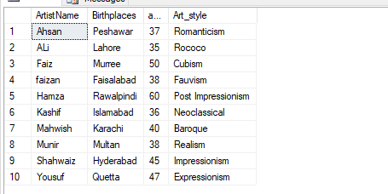

**Insert Data in pieceofNetwork TAble**

insert into pieceofNetwork (Year,titleofArtWork,Art_type,price,groupname,Art_title) values ('1996','Unconceptual','painting',100,'portraits','Mahwish')

insert into pieceofNetwork (Year,titleofArtWork,Art_type,price,groupname,Art_title) values ('2000','Black Letters','lithograpgh',200,'still lifes','Ali')

insert into pieceofNetwork (Year,titleofArtWork,Art_type,price,groupname,Art_title) values ('2005','List','sculpture',400,'works by Picasso','Kashif')

insert into pieceofNetwork (Year,titleofArtWork,Art_type,price,groupname,Art_title) values ('2004','Flat Shadow','photography',300,'works of the 19th century','Ahsan')

insert into pieceofNetwork (Year,titleofArtWork,Art_type,price,groupname,Art_title) values ('2008','Try Harder','sculpture',400,'portraits','Munir')

insert into pieceofNetwork (Year,titleofArtWork,Art_type,price,groupname,Art_title) values ('2014','Roadkill','photography',300,'still lifes','Sahwaiz')

insert into pieceofNetwork (Year,titleofArtWork,Art_type,price,groupname,Art_title) values ('2015','Another Show','lithograph',400,'works by Picasso','Hamza')

insert into pieceofNetwork (Year,titleofArtWork,Art_type,price,groupname,Art_title) values ('2017','Holes in the wal','sculpture',200,'works of the 19th century','Faizan')

insert into pieceofNetwork (Year,titleofArtWork,Art_type,price,groupname,Art_title) values ('2010','Awful Things','photography',300,'portraits','Yousuf')

insert into pieceofNetwork (Year,titleofArtWork,Art_type,price,groupname,Art_title) values ('2011','No Negative','painting',400,'still lifes','Faiz')

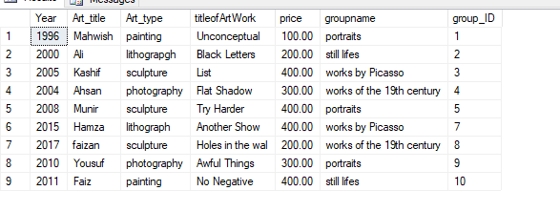

**Insert Data in Customer TAble**

insert into Customer values ('Sajd','123A',2000,'Ali')

insert into Customer values ('Saqib','123B',1500,'Kashif')

insert into Customer values ('Musab','123C',4500,'Ahsan')

insert into Customer values ('Saad','123D',3000,'Munir')

insert into Customer values ('SArim','123E',4000,'Sahwaiz')

insert into Customer values ('Subhan','123F',5000,'Hamza')

insert into Customer values ('MAjid','123G',1000,'Faizan')

insert into Customer values ('Aqib','123I',5555,'Yousuf')

insert into Customer values ('Sara','123J',3999,'Faiz')

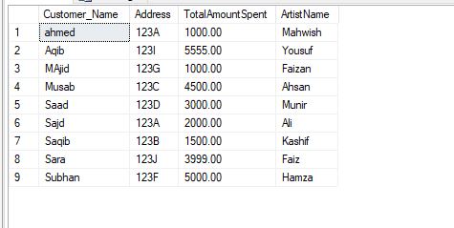

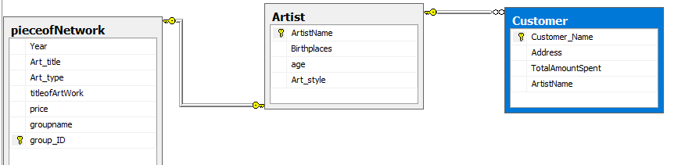

1. select * from Artist where ArtistName like '[^0-9]%sh%'

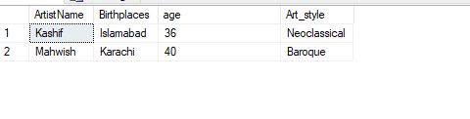

1. select top 5 * from pieceofNetwork order by price DESC

